**SYEDA FATIMA SHAH**

**21st March 2023**

***Task # 3:***

**Write a few lines about these terms with examples:**

**-What is SQL?**

SQL stands for Structured Query Language, which is a standard programming language designed for managing and manipulating relational databases (RDBMS) such as MySQL, Oracle, Microsoft SQL Server, and PostgreSQL, among others. It is also used in other applications that require data management, such as websites, mobile apps, and enterprise software.

SQL commands are written in a specific syntax that enables users to interact with databases and perform various tasks, and it uses declarative statements to retrieve, store and manage data in a database.

**-What is DDL?**

DDL stands for Data Definition Language, which is a set of SQL commands used to define and manage the structure of a database. DDL statements are used to create, modify, and delete database objects such as tables, indexes, views, and procedures.

Some common DDL commands include:

CREATE: used to create a new database object such as a table, view, or index

ALTER: used to modify the structure of an existing database object

DROP: used to delete a database object

TRUNCATE: used to delete all the data in a table

DDL commands are important for managing the structure and organization of data in a database, and they are typically used by database administrators or developers.

**-What is DML?**

DML stands for Data Manipulation Language, which is a set of SQL commands used to manage data within a database. DML statements are used to insert, update, delete, and retrieve data from a database.

Some common DML commands include:

INSERT: used to add new data to a table

UPDATE: used to modify existing data in a table

DELETE: used to remove data from a table

SELECT: used to retrieve data from one or more tables

DML commands are essential for managing the content of a database, and they are often used by developers, analysts, and other users who need to access and manipulate data.

**-What us DQL?**

DQL stands for Data Query Language, which is a subset of SQL used to retrieve data from one or more tables in a database. DQL commands are used to perform queries on a database, and they include commands such as SELECT, FROM, WHERE, GROUP BY, and HAVING.

They allow users to retrieve specific data from a database by specifying criteria or conditions, such as searching for data based on a certain value or sorting data based on specific criteria. They are used by a wide range of users, including developers, analysts, and business users who need to retrieve data for reporting and analysis purposes.

Some common DQL commands include:

SELECT: used to retrieve data from one or more tables

FROM: used to specify the tables to retrieve data from

WHERE: used to specify conditions that the retrieved data must meet

GROUP BY: used to group retrieved data based on a specific column or set of columns

HAVING: used to specify conditions for the groups created by the GROUP BY clause

Overall, DQL is an important part of SQL that is used extensively in database applications to retrieve, filter, and manipulate data.

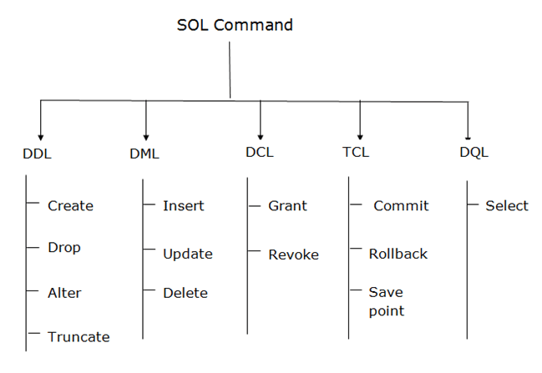

***Task #4:***

**Practice about following in SSMS:**

**-Creating a Database.**

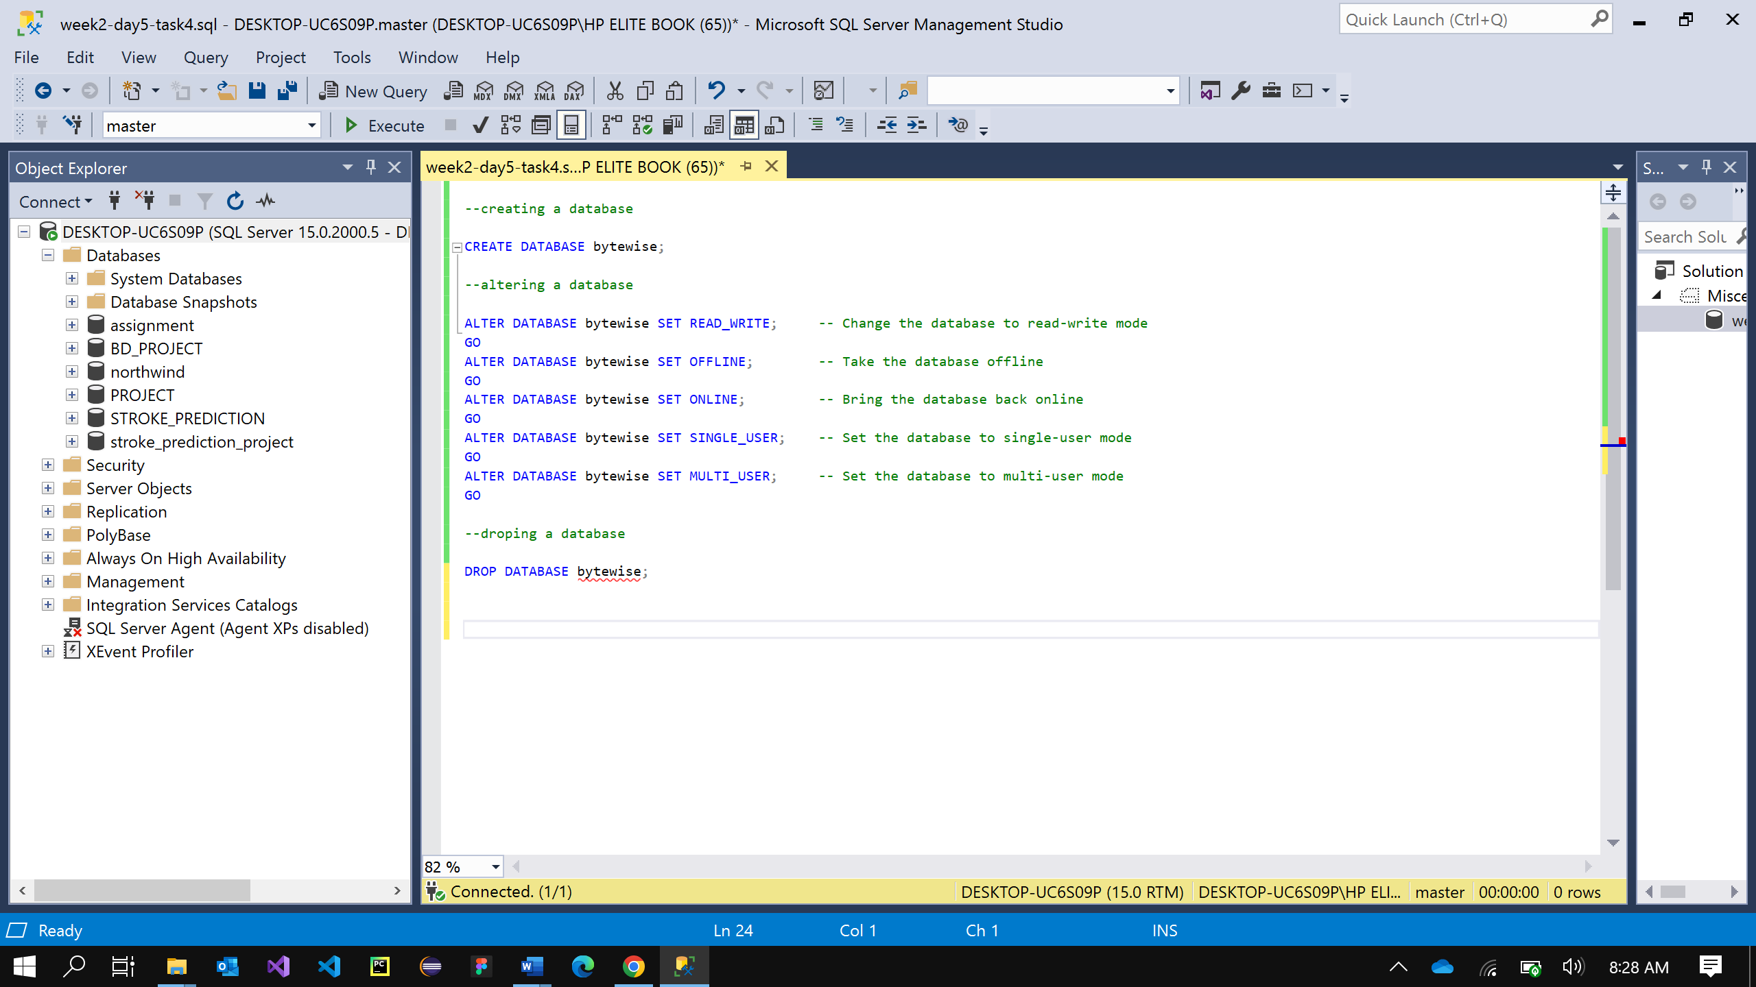

**-Altering a Database.**

**-Deleting a Database.**

**Save the query file for task 4 and the document of task 3 into your forked github repository when you complete the task.**